IN605 Databases 2
IN605 Data Model Assignment
Tanvi Ashok

Main Objectives:
The main objective of this database is to design a system that will computerise information instead of making it repetitious. The database is going to try and meet the following aspects:
- Registration and re-registration. Getting the information from the rugby union and confirming true for registration:
At the moment this process is fairly manual for registering new and returning students. The union sends forms of last year’s registrations, they are then printed off, details checked with and then taken through a process of re-registering and paying. These details are then sent to the coaches who update their details. All this information is then collated and then put into a current spreadsheet. Information from the rugby union is all on paper but is basic in detail. The union has its own database and this is what Ms Dyer works with. A basic A4 content sheet is printed off with details on it and this is sent around for the registration where one has to sign agreeing to terms and conditions. Students registering for the first time fill out a blank sheet with their details and once the office admin have all the information it is then entered into separate spreadsheets for each team.

- Contact details and assigning teams:
The data that is needed by the rugby club are names, addresses, parent/caregivers names – there can only be one or two caregivers, email ids, and phone numbers – cell phone and landline. Medical information is also required so that the coaches are aware of medical conditions, if any. Players usually sign up from the ages of four or five and usually carry on till they are thirteen.

- Tracking gear:
Each player is allocated a rugby jersey. They record the number of the jersey and also record the receipt number when the player pays. Coaches also get allocated with a track suit and they have a similar numbering system like they have for the jerseys.

- Newsletters and mail merging:

- Linking players with parents:
Each family can have more than one child therefore parents/caregivers need to be linked. Split families also need to be taken into account.

- Union handles draws of which team played where and when:
The union keeps a record of the scores of the teams that played where and when.
The children’s rugby club even has a small shop during home games where volunteers help out. An inventory system for the shop is out of the scope at the moment as they want to get a database system in order before an inventory system.

Use Cases:

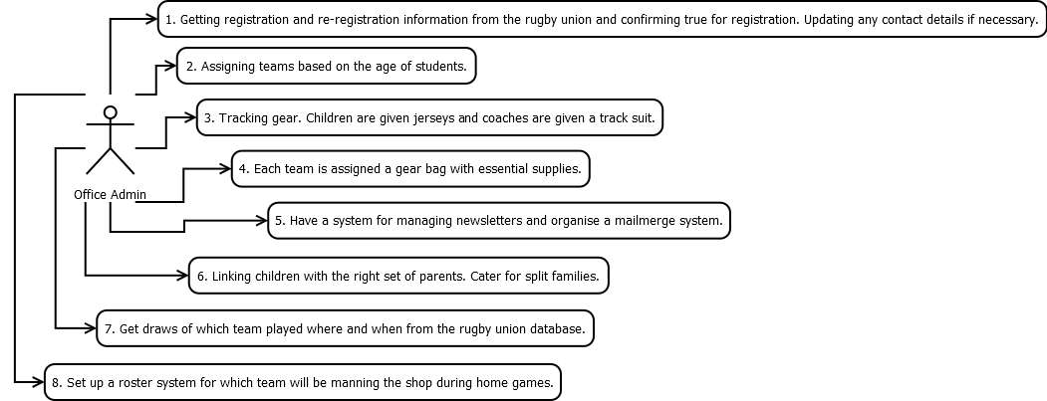

Conceptual Data Model:

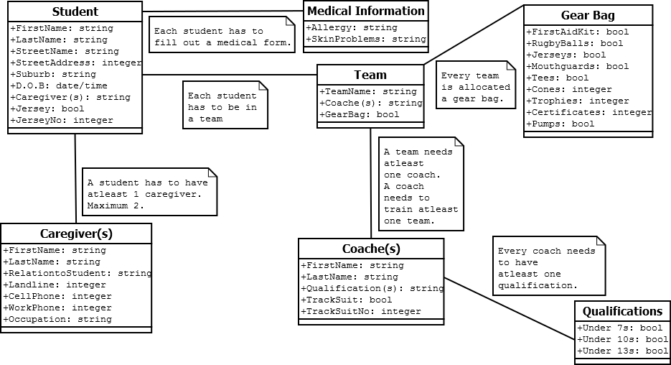

Data Dictionary:
Table Name | Data type | Description
Student
First Name | String | The first name of the student
Last Name | String | The last name of the student
Street Name | String | Street student lives on
Street Address | Integer | House number student lives
Suburb | String | Part of town student lives in
D.O.B | Date/Time | Date of Birth of student
Caregiver(s) | Integer | Number of caregivers. Can have a maximum of two.
Jersey | Boolean | Can be a check box to ensure the student has been given a jersey.
Jersey No | Integer | Individual jersey serial number to identify who it has been given to.
Caregiver(s)
First Name | String
Last Name | String
Relation to Student | String | This is going to be linked to the table Relation and is going to be a drop down menu
Landline | Integer
Cell Phone | Integer
Work Phone | Integer
Occupation | String | Part of getting details of caregiver(s)/parents.
Coach(e)(s)
First Name | String
Last Name | String
Qualifications | String | This is going to be linked to the table called Qualifications and is going to be drop down menu
Track Suit | Boolean | Can be a check box to ensure the coach has been supplied with a track suit
Track Suit No | Integer | Individual track suit serial number to identify which coach it has been assigned to
Medical Info
Allergy | String | This is going to be linked to a table called Allergies and is going to be a drop down menu
Skin Problems | String | This is going to be linked to another table called Skin Problems and is also going to be a drop down menu
Team
Team Name | String | Linked to a table called Teams Playing and have a drop down menu.
Coach(e)(s) | String | Will be linked to the coaches table.
Gear Bag | Boolean | Each team is assigned their own gear bag with supplies. This is going to be checkbox.
Gear Bag
First Aid Kit | Boolean | Check Box
Rugby Balls | Boolean | Check Box
Jerseys | Boolean | Check Box
Mouth guards | Boolean | Check Box
Tees | Boolean | Check Box
Cones | Integer | No of cones in the bag
Trophies | Integer | No of trophies for the end of the game
Certificates | Integer | No of certificates for the end of the game
Pumps | Boolean | Check Box
Qualifications
Under 7s | Boolean | Check Box
Under 10s | Boolean | Check Box
Under 13s | Boolean | Check Box
Note: The table qualifications will be linked to the attribute qualifications in the table coaches so that when entering information about the coaches the office administrator can choose them.

